**MAJOR PROJECT I** END-SEMESTER REPORT ON

**OBJECT DETECTION UNDER CAMOUFLAGE**

SUBMITTED BY:

Akhand Pratap (R2214201498, 500085043)

Jasmine Wadhwa (R2214201778, 500086813) Vishal Thakur(R2214201315, 500084112)

Radhika Deshmukh(R178218042, 500071050)

***Under the guidance of:***

Mr. Gaytri



# Department of Cybernetics School of Computer Science

**UNIVERSITY OF PETROLEUM AND ENERGY STUDIES**

## Dehradun- 248007



**Major I: OBJECT DETECTION UNDER CAMOUFLAGE**

# OBJECTIVE

1. Build a model to detect objects’ boundaries under a Camouflaged environment in low illumination condition.
2. Qualitative and Quantitative  Analyisis of the model

# ABSTRACT

Camouflaged object detection (COD), which aims to identify objects that are “seamlessly” embedded in their surroundings using deep learning. There are many potential applications where we need techniques of decamouflaging like: distinguishing original from the hidden such as military applications and autonomous object detection systems where identification of objects within Camouflage image is essential. The implementation is carried out in different environments. This project enlightens a methodology which would detect an object from same or complex background

**INTRODUCTION**

Background matching camouflage. That is what biologists call it when an animal adapts their body’s coloring to match with their surroundings in order to avoid recognition. It works by deceiving the visual perceptual system of the observer. The high intrinsic similarities between the target object and the background make COD far more challenging than the traditional salient object detection. In addition to its scientific value, COD is also beneficial for applications in the fields of computer vision (for search-and-rescue work, or rare species discovery), medical image segmentation (e.g., polyp segmentation, lung infection segmentation agriculture (e.g., locust detection to prevent invasion), and art (e.g., for photo-realistic blending or recreational art. Because of its high importance the research into this subject can’t be undermined and therefore, it’s highly important. This report depicts following sections such as Chapter 3 portrays problem statement which talks about

a generalized problem dealing with camouflage environment, chapter 4 depicts Methodology which showcases the workflow and the techniques adopted, Chapter 5 displays the Literature review and chapter 6 describes the goals to achieve the correct results.

# DEFINITION

Object detection under Camouflage is the detection of objects that are ‘seamlessly’ embedded under surroundings which can also be under various environmental conditions such as haze,fog,low illumination etc. using Deep Learning:

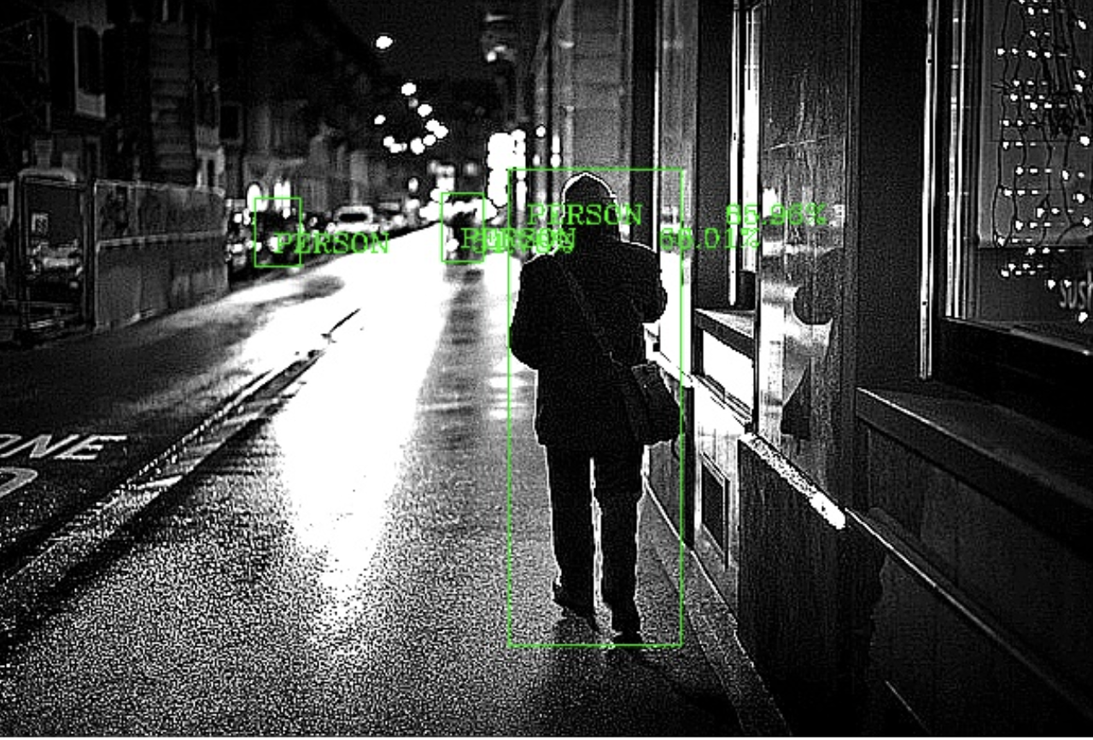 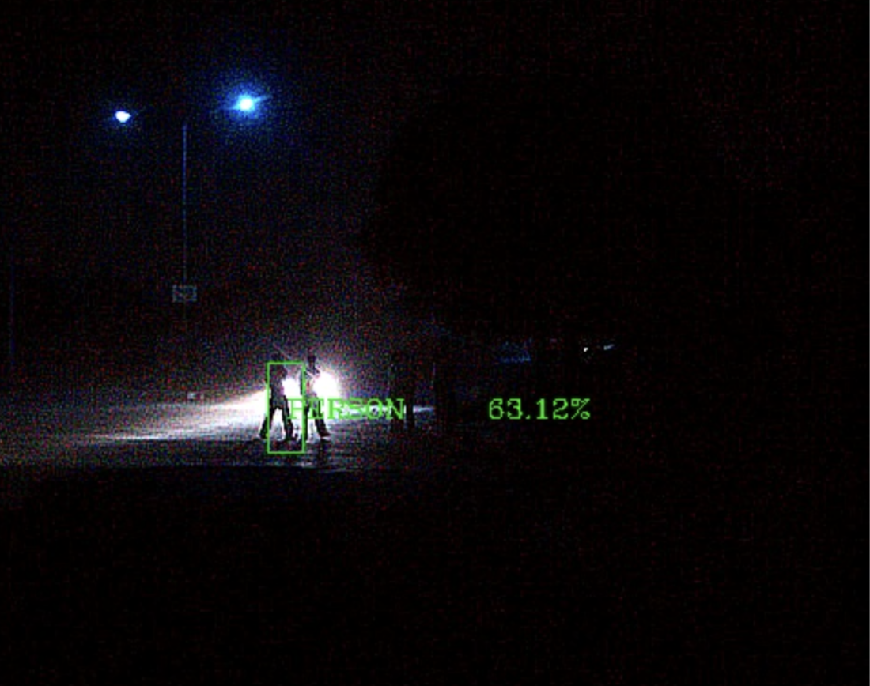

# 

# LITERATURE REVIEW

**Malathi. T and Manas Kamal** **Bhuyan** proposed camouflage object detection using codebooks. The background pixels were quantized into codebooks which stand for background. Subsequently, it separates out the foreground object from the background. When the confusion between object color and background color has occurred, then disparity map is extracted from the different views of the foreground. In this approach, it is seen that the intrinsic and extrinsic parameters of the camera also affect the calculation of disparity value [1]. Camouflage Modeling for moving object detection. This method was proposed by author Xiang Zhang, Ce Zhu, Senior Member, IEEE, Shuai Wang, Yipeng Liu, and Mao Ye it uses camouflaged modeling (CM), discriminative modeling (DM)and sheikh alogorithm,GMM algo, cuevas algorithm, Patwardhan algo,elegammal algo (for CM Testing) Technology and trained using cuevas,GMM,ViBe,CM database [2]. Another author Xianf Zhang et al proposed another approach using Bayesian method in their method using discriminative modelling to identify foreground pixels that are not camouflaged while leveraging camouflage modelling to identify foreground pixels that are. Discriminative feature-based modelling improves the performance of separating the foreground from the background with discriminative features, but it fails to detect moving objects that are camouflaged. For the foreground, an integration of universal and local models is constructed, while a universal model is developed for the background.

**Rethinking Camouflaged Object Detection**: Models and Datasets. This paper is a detailed review of the COD frameworks and its datasets. It merely classifies the existing models into two feature base models and the deep learning models. The author Hongbo Bi1, Member, IEEE, Cong Zhang1, Kang Wang, Jinghui Tong, Feng Zheng* conducted an experiment on seven typical COD Network based deep learning on four public benchmarks. And additionally, discussed the limitations of the existing model in the current stage and their solution [4]. Zoom in and Out a Mixed-Scale Triplet Network for Camouflaged., the author has used a mixed scaled triple network which simulates the very human nature of zooming in and out when viewing hazy images. Numerous experiments show that the proposed method performs better than the most advanced methods already in use for the COD [5]. Deeper Look at Image Salient Object Detection: Bi-Stream Network with a Small Training Dataset. The authors Zhenyu Wua ,Shuai Lia ,Chenglizhao Chenab, Aimin Haoade, Hong Qinc have provided a deeper insight b/w the ISOD performance and the training dataset. They built a small, hybrid, and semantic category balanced new training set. The author offers a paradigm for efficiently creating a training set to improve performance. To fully utilise the proposed small-scale training set, they have proposed a new bi-stream architecture with a gate control unit and multi-layer attention. The suggested bi-stream network can attain new SOTA performance, as shown by extensive quantitative comparisons and component evaluations. It was trained using the new small-scale training dataset [6]. Camouflaged Object detection the authors have provided a new challenging and densely annotated COD10K dataset, conducted a large-scale evaluation, developed a simple but efficient end-to-end SINet framework, and provided several potential applications. Compared with existing cutting-edge baselines, SINet is competitive and generates more visually favorable results. The above contributions offer the community an opportunity to design new models for the COD task. [7] Mutual Graph Learning for Camouflaged Object Detection. This paper has presented Mutual graph learning (MGL), a graph-based, joint Learning framework for detecting camouflaged objects and their true edges. The model has two neural networks modules Region-Induced Graph Reasoning (RIGR) module and Edge-Constricted Graph Reasoning (ECGR) module, which cooperates to retrieve important integral data for further developing the real edge perceivability for COD. The authors have formulated the MGL as recurrent graph reasoning process to exploit all the information available.[8] Still there were some accuracy issues in detection of objects hence introduced Boundary guidance network for camouflage object detection. To obtain accurate camouflaged maps with sharp boundaries, this paper proposes a new Boundary guidance network which consists of an initial localization decoder and residual refinement decoder. The experiment shows that the proposed model fundamentally outflanks existing cutting-edge calculations on four benchmark datasets, and with benefits in limit exactness and mode minimization [9].

Cascade and Fusion: A deep learning approach for camouflaged object sensing. In this paper, the author proposed another system for COD, to be specific CODCEF. CODCEF comprises two somewhat free and flowing perceptual modules. Contrasted and customary single encoder-decoder structures, our engineering showed more grounded location exactness and power. To embrace the element translating undertaking of CODCEF, we utilized a Cross Component Module to construct an Input Fractional Decoder (FPD (Feedback Partial Decoders)), which successfully decreased misdirecting data achieved by cover pictures. Also, we proposed the clever misfortune capability Pixel Insight Combination Misfortune (PPF) to moderate conceivable objective edges [10].

CCA: Exploring the Possibility of Contextual Camouflage Attack on Object Detection. This paper investigated the problems of learning contextual adversarial objects camouflage to attack vehicle detectors such as YOLOv3 And YOLOv5, and then proposed an algorithm to learn highly effective camouflages by interacting with a photo simulation. The CAA algorithm not only shows the effectiveness of attacking the highly effective object detectors, but also shows the capability to increase the effectiveness of the detectors.[11]

# METHODOLOGY

We shall achieve our goal in the following phases:

1. We first take the input data sets for the camouflaged object detection that can be used for image processing
2. Preprocessing is crucially dependent on feature extraction method and input image type.
3. An object detection model is proposed to classify the object from the camouflage
4. Due to several similarities between the object and the background it is very hard to disassociate the object from the background. Instead of detecting the whole target object directly, we supervise the model for detecting the object from its conspicuous region.

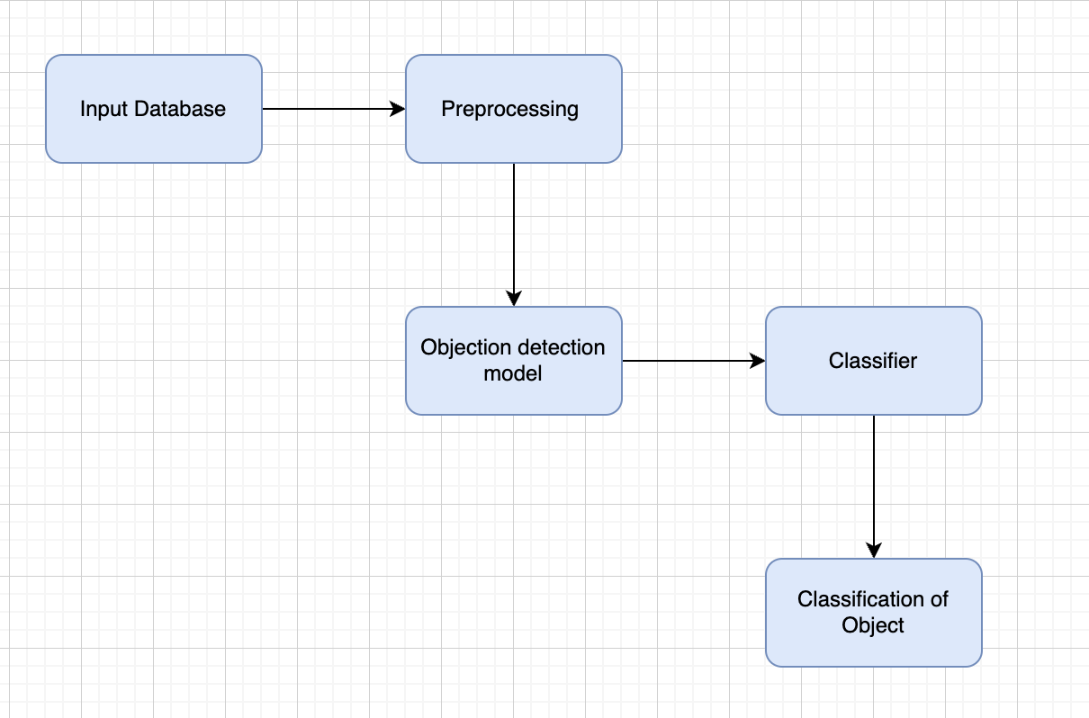

**ALGORITHMS IMPLEMENTED:**

## SSDNet

SSD is designed for object detection in real-time. Faster R-CNN uses a region proposal network to create boundary boxes and utilizes those boxes to classify objects. While it is considered the start-of-the-art in accuracy, the whole process runs at 7 frames per second. Far below what real-time processing needs. SSD speeds up the process by eliminating the need for the region proposal network. To recover the drop in accuracy, SSD applies a few improvements including multi-scale features and default boxes. These improvements allow SSD to match the Faster R-CNN’s accuracy using **lower resolution images**, which further pushes the speed higher.

SSD has two components: a backbone model and SSD head. Backbone model usually is a pre-trained image classification network as a feature extractor.

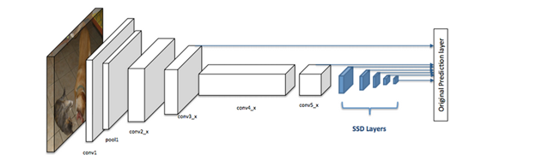

2. Mobile net SSD

Mobile Net is an object detector released in 2017 as an efficient CNN architecture designed for mobile and embedded vision application. This architecture uses proven depth-wise separable convolutions to build lightweight deep neural networks.

The first part consists of the base MobileNetV2 network with a SSD layer that classifies the detected image. In essence, the MobileNet base network acts as a feature extractor for the SSD layer which will then classify the object of interest.

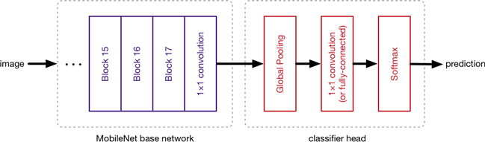

# TASK ACCOMPLISHED

## Gathered all the data required for our model:

In order to facilitate a new object detection and image enhancement research particularly in the low-light environment, we introduce the Exclusively Dark (ExDark) dataset. The Exclusively Dark (ExDARK) dataset is a collection of 7,363 low-light images from very low-light environments to twilight (i.e 10 different conditions) with 12 object classes and we are choosing people class.

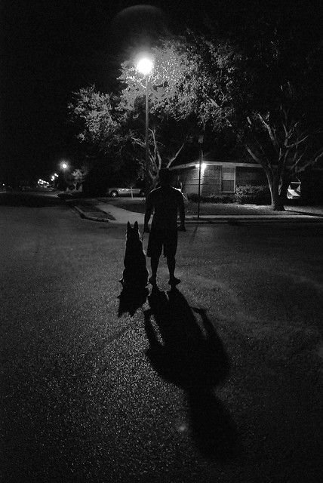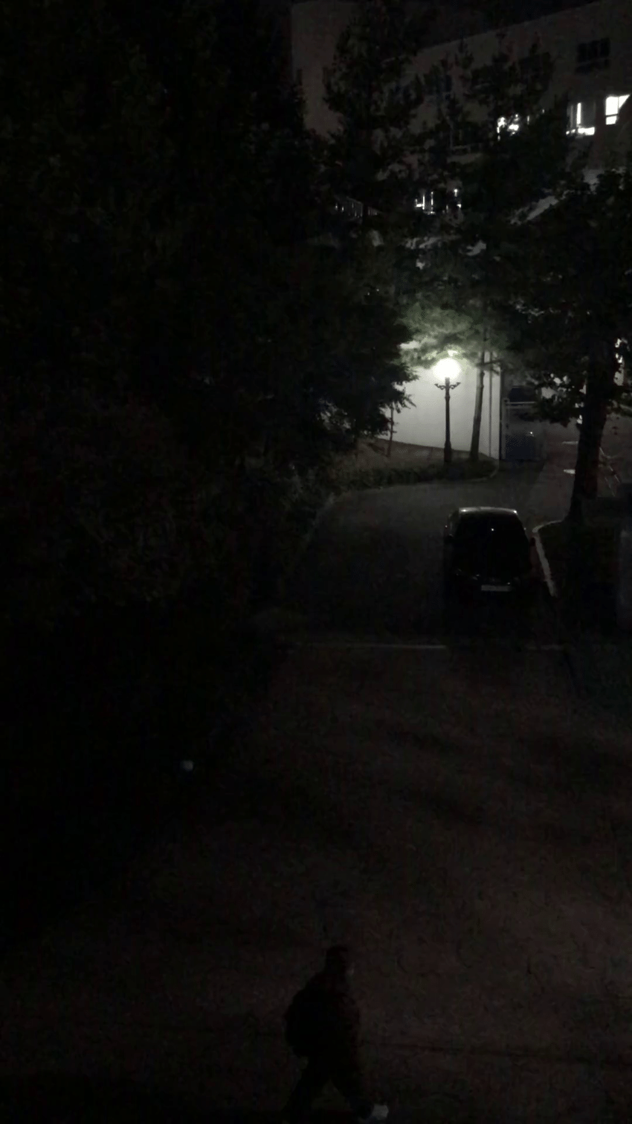

## Created class to enhanced an image:

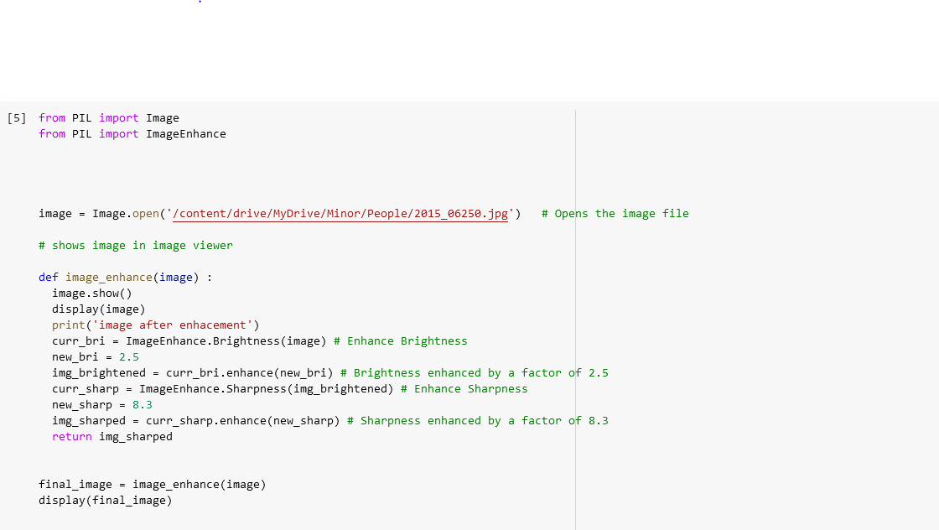

1. **Image is passed through mobile net ssd to detect the object under camouflage.**

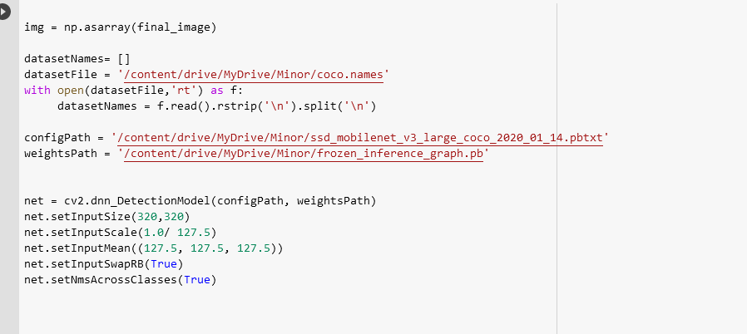

## Labeling of the image is done after identifying it.

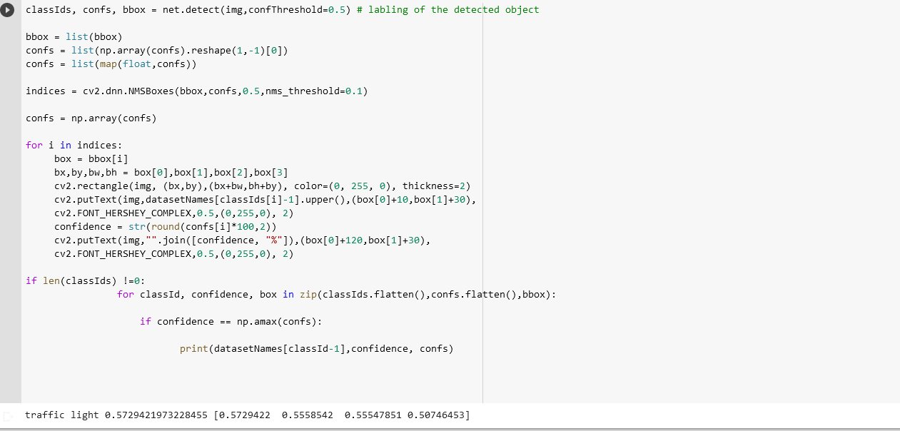

1. **Image is saved after labeling it.**

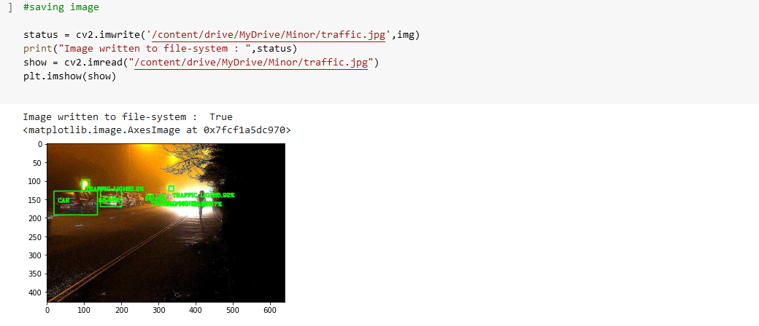

## Implemented on image :

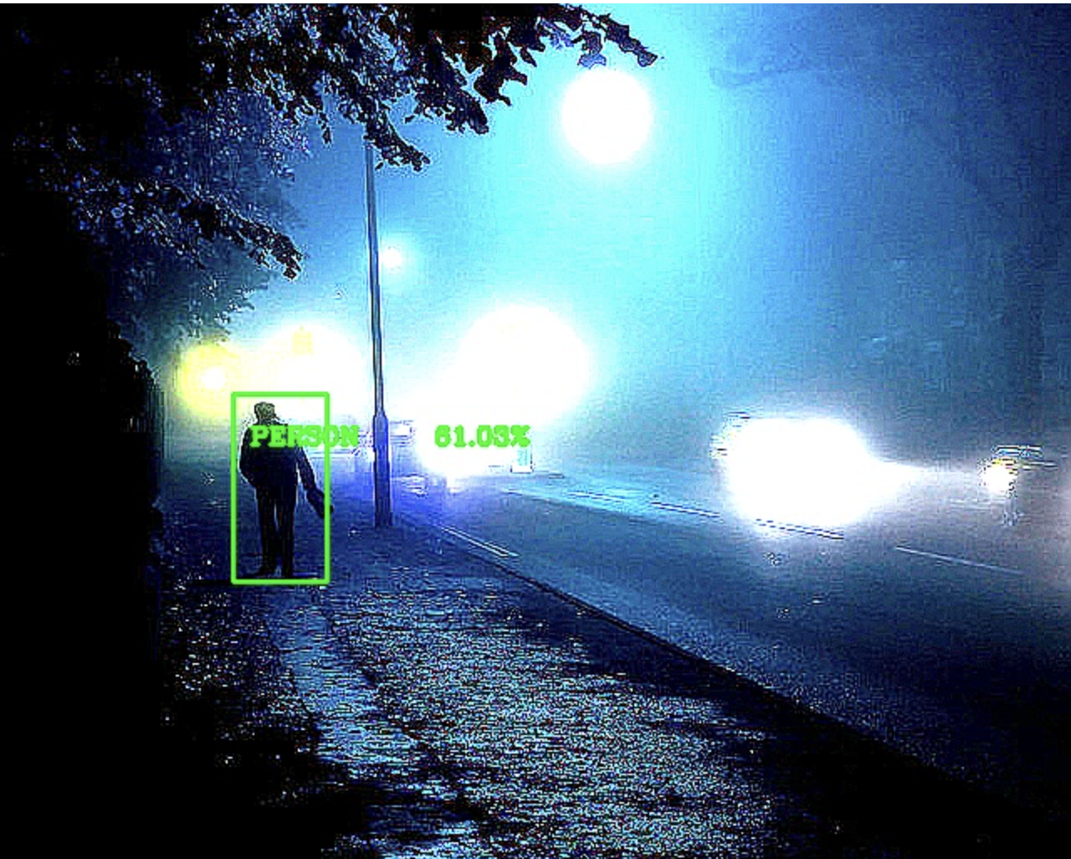

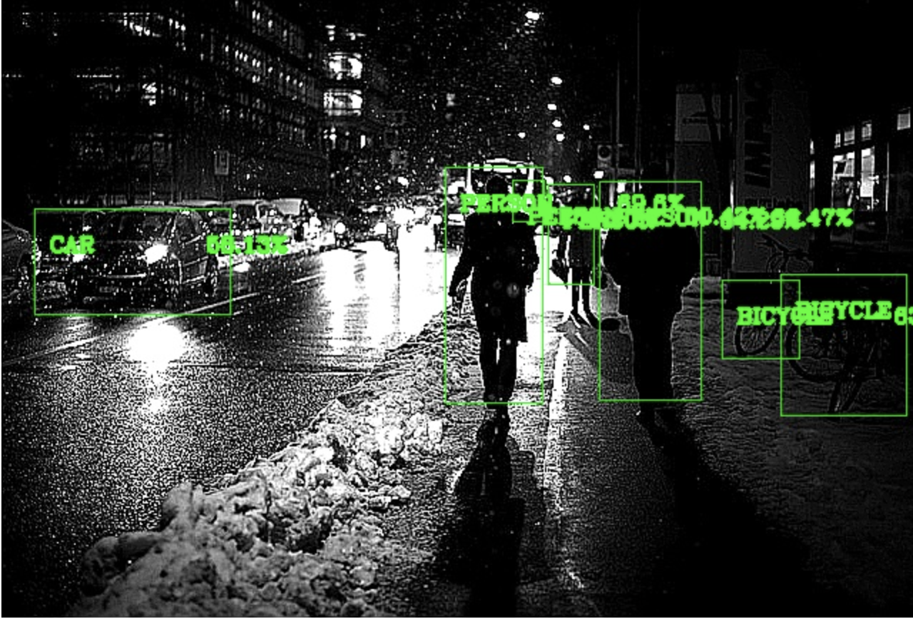

7. Qualitative Analysis by training and testing Ex Dark Data set Images.

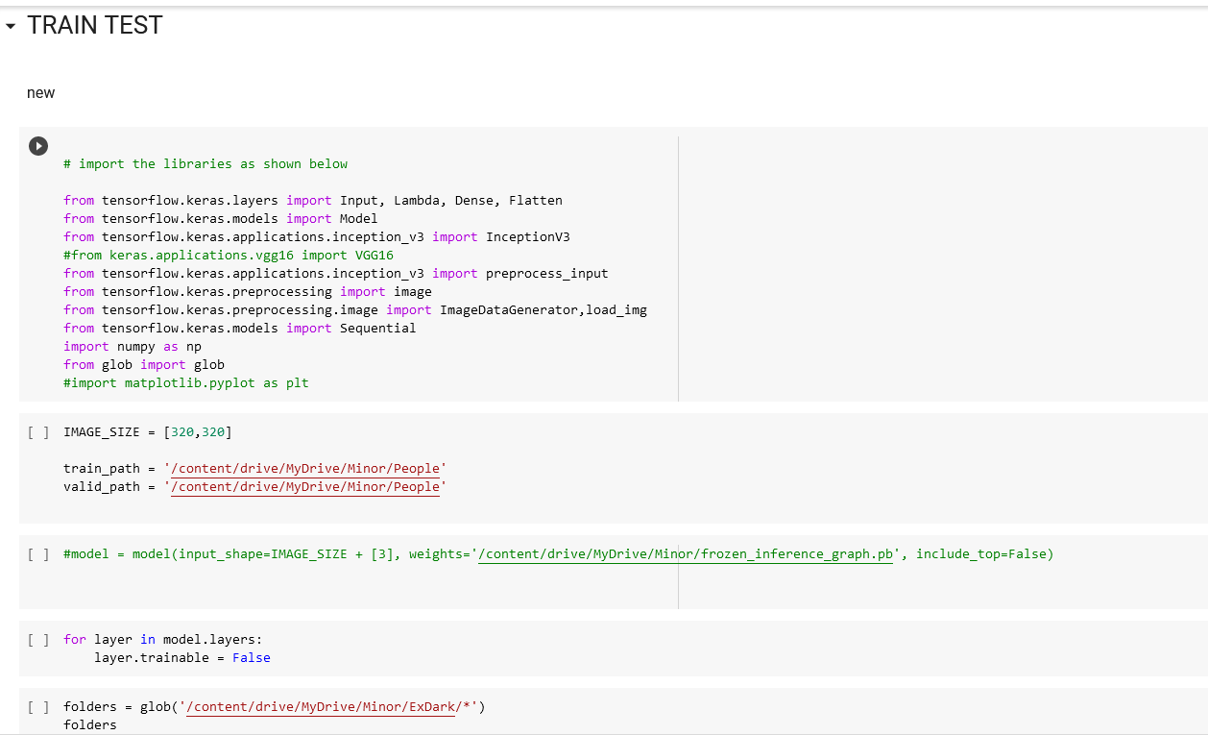

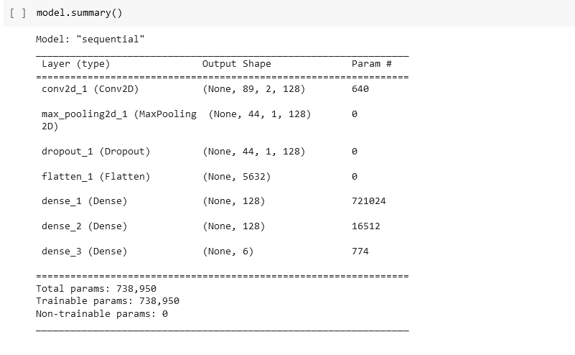

To perform qualitative analysis Ex Dark data set images were taken into consideration for training model while 14,779 of the data set images were taken for testing.

As per our calculation Average detection rate for 413 objects that included people,tv ,chair like objects is 0.68656.

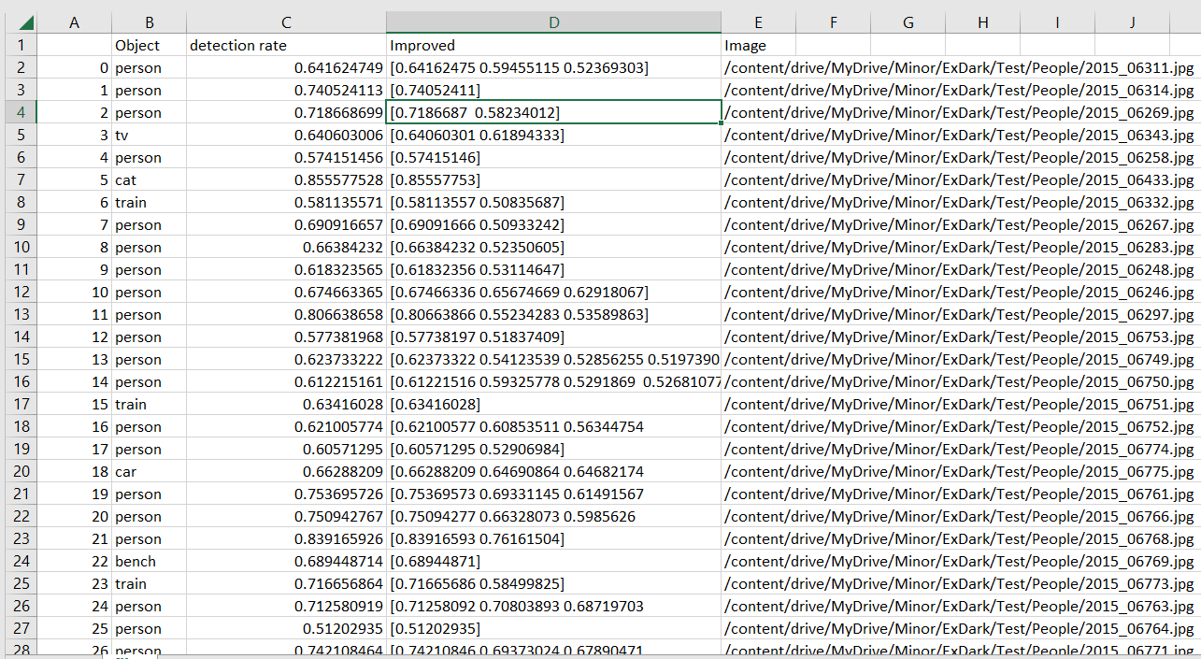

# FUTURE WORKS:

* To implement our work on other indetectable objects that fall under objects under camouflage. Objects that are further hard to trace under the camouflage object detection models.
* Implementation on IOT devices for real time use.

# REFERENCES

[1] Zhai, Q., Li, X., Yang, F., Chen, C., Cheng, H., & Fan, D. P. (2021). Mutual graph learning for camouflaged object detection. In *Proceedings of the IEEE/CVF Conference on Computer Vision and Pattern Recognition* (pp. 12997-13007).

[2] Xu, X., Zhu, M., Yu, J., Chen, S., Hu, X., & Yang, Y. (2021). Boundary guidance network for camouflage object detection. *Image and Vision Computing*, *114*, 104283.

[3] Zhang, X., & Zhu, C. (2015, July). Camouflage modeling for moving object detection. In *2015 IEEE China Summit and International Conference on Signal and Information Processing (ChinaSIP)* (pp. 249-253). IEEE.

[4] Yang, F., Zhai, Q., Li, X., Huang, R., Luo, A., Cheng, H., & Fan, D. P. (2021). Uncertainty-guided transformer reasoning for camouflaged object detection. In *Proceedings of the IEEE/CVF International Conference on Computer Vision* (pp. 4146-4155).